



UK & Ireland Carbon Reduction Plan

Supplier name: Adecco Group UK & Ireland
Publication date: July 2025 Current Emission Reporting:
1st January 2024 - 31st December 2024

Commitment to achieving Net Zero
Adecco Group UK & Ireland is committed to achieving Net Zero emissions by 2050.

Baseline Emissions Footprint
Baseline emissions are a record of the greenhouse gases that have been produced in the past and were produced prior to the introduction of any strategies to reduce emissions. Baseline emissions are the reference point against which emissions reduction can be measure.

Baseline Year: 2019
Additional Details relating to the Baseline Emissions calculations.
2019 was the first year of reported Carbon Emissions data. Therefore, 2019 data represents the Adecco Group UK&I Baseline Emissions, against which it measures efforts towards achieving net zero.
Baseline year emissions:
EMISSIONS | TOTAL (tCO2e)
Scope 1 | 206.58
Scope 2 | 650.97
Scope 3  (Included Sources) | 3990.70  Upstream Transportation and Distribution: 0  (Adecco does not have any upstream or downstream emissions)  Waste Generated in Operations: 0  Waste was not assessed in 2019, as it was not required at the time. Due to immateriality, relating to current footprint as per GHG protocol, this has not been retrospectively estimated.  Business Travel: 1739.07  Employee Commuting:1082.83  (Adecco Group UK&I did not report on this element for 2019 but this has been retrospectively estimated*.  Downstream Transportation and Distribution: 0  (Adecco Group UK&I does not have any upstream or downstream emissions)
Total Emissions | 4848.24 (Location and Market Based same)  *In accordance with the market-based reporting hierarchy and GHG protocol we have carried out a recalculation of baseline emissions in the data above due to material additions. The market-based electricity and location-based electricity emissions however remain the same. This is because the location-based value has been used as proxy due to the lack of supplier specific emissions for market-based reporting to be retrospectively calculated.

Prior Year Emission Reporting

Reporting Year: 2023 Assessment Period: 1st January 2023 -31st December 2023
EMISSIONS | TOTAL (tCO2e)
Scope 1 | 82.95
Scope 2 | 369.95 (Location Based), 360.99 (Market Based)
Scope 3  (Included Sources) | 3564.92 (Location Based), 3550.87 (Market Based)  Upstream Transportation and Distribution: 0 Downstream Transportation and Distribution: 0  (Our carbon reporting and assessment has been more aligned to SECR [Streamlined Energy & Carbon Reporting] and therefore primarily focused on scopes 1 & 2 GHG [Green House Gas] and partial Scope 3 emissions).  Waste Generated in Operations: 0  Due to immateriality, relating to current footprint as per GHG protocol, Adecco Group UK&I did not report on this metric.  Business Travel: 1635.68  Employee Commuting: 962.70
Total Emissions | 4017.82 (Location Based) 3994.81 (Market Based)

Current Emission Reporting

Reporting Year: 2024 Assessment Period: 1st January 2024 -31st December 2024
EMISSIONS | TOTAL (tCO2e)
Scope 1 | 30.25
Scope 2 | 273.98 (Location Based), 265.75 (Market Based)
Scope 3  (Included Sources) | 2897.33 (Location Based), 2896.80 (Market Based)  Upstream Transportation and Distribution: 0 Downstream Transportation and Distribution: 0  (Our carbon reporting and assessment has been more aligned to SECR [Streamlined Energy & Carbon Reporting] and therefore primarily focused on scopes 1 & 2 GHG [Green House Gas] and partial Scope 3 emissions).  We increased our assessment for 2024 to include commuting & Homeworking for our colleagues.  Waste Generated in Operations: 0.19  Business Travel: 1566.06 (Location Based), 1566.58 (Market Based)  Employee Commuting: 1330.56
Total Emissions | 3744.31 (Location Based) 3690.21 (Market Based)

Emissions reduction targets
To continue our progress to achieving Net Zero, we have adopted the following carbon reduction targets. We project that carbon emissions per £M turnover will decrease over the next five years to 2884.71 tCO2e by 2029. This is a reduction of 22%. Progress against these targets can be seen in the graph below.
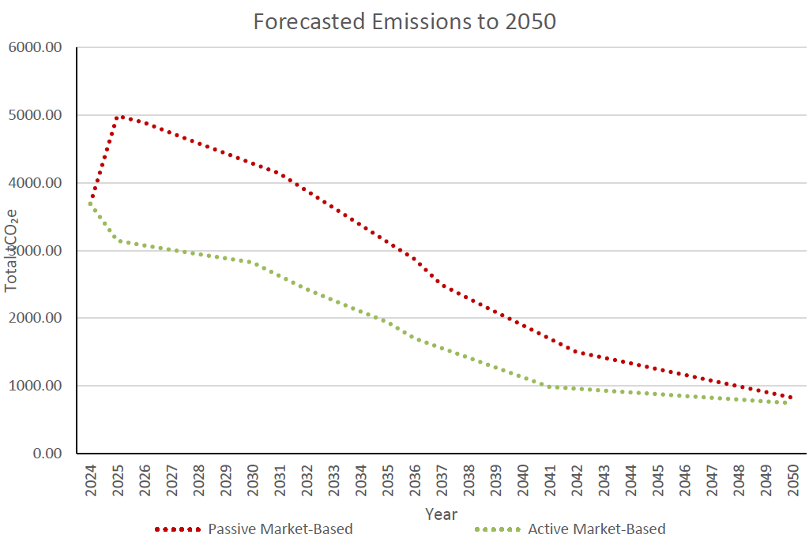

Completed Carbon Reduction Initiatives

The following environmental management measures and projects have been completed or implemented in the UK and Ireland since the 2019 baseline:
Completed carbon reduction projects centered on a continuation of better use of floor space across the UK and moving more of the Group portfolio to greener energy tariffs. This approach significantly reduced overall energy emissions.

Policies have been introduced for flights under 6 hours to be flown economy class
Energy efficient lighting has been introduced across all sites
Energy use is centrally monitored across UK & Ireland locations

Adecco operates a strategic Environmental Committee and tactical sub-groups. This enables us to progress carbon reduction project initiatives and associated activity. The current roadmap for carbon reduction projects includes:

- Renewable energy tariff optimisation / increase in lower energy use infrastructure/equipment
- Business travel reduction (i.e., road, air, sea)
- Vehicle optimisation (i.e., electric, hybrid)
- Monitoring/reducing employee commute.

The carbon emission reduction achieved by these schemes to date equates to 1158.03 tCO2e, or 24% reduction from the 2019 baseline year, based on its absolute emissions. Measures will be in effect when performing the contract to further reduce carbon emissions.

Declaration and Sign Off
This carbon reduction plan relates solely to Adecco Group UK and Ireland entities, and supplements Adecco Group global carbon reporting. Variances when compared to Adecco Group global reporting may exist due to different reference periods and differences in scope.

This Carbon Reduction Plan has been completed in accordance with PPN 06/21 and associated guidance and reporting standard for Carbon Reduction Plans.
Emissions have been reported and recorded in accordance with the published reporting standard for Carbon Reduction Plans and the GHG Reporting Protocol corporate standard¹ and use the appropriate Government emission conversion factors for greenhouse gas company reporting².

Scope 1 and Scope 2 emissions have been reported in accordance with SECR requirements, and the required subset of Scope 3 emissions have been reported in accordance with the published reporting standard for Carbon Reduction Plans and the Corporate Value Chain (Scope 3) Standard.

This Carbon Reduction Plan has been reviewed and approved as detailed below.

Signed:
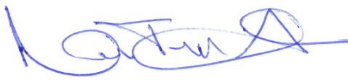
Date: 8th July 2025

Niki Turner-Harding
Country Head, Adecco Group UK&I

- https://ghgprotocol.org/corporate-standard
- https://www.gov.uk/government/collections/government-conversion-factors-for-company-reporting
- https://ghgprotocol.org/standards/scope-3-standard




